GrID Authentication using PHP
and

Powerful Authentication Management for Service Providers and Enterprises

Copyright © 2012 SafeNet, Inc. All rights reserved.
All attempts have been made to make the information in this document complete and accurate. SafeNet, Inc. is not responsible for any direct or indirect damages or loss of business resulting from inaccuracies or omissions. The specifications contained in this document are subject to change without notice.
SafeNet and SafeNet Authentication Service are either registered with the U.S. Patent and Trademark Office or are trademarks of SafeNet, Inc., and its subsidiaries and affiliates, in the United States and other countries. All other trademarks referenced in this Manual are trademarks of their respective owners.
SafeNet Hardware and/or Software products described in this document may be protected by one or more U.S. Patents, foreign patents, or pending patent applications.
Please contact SafeNet Support for details of FCC Compliance, CE Compliance, and UL Notification.
Support
SafeNet technical support specialists can provide assistance when planning and implementing SafeNet Authentication Service. In addition to aiding in the selection of the appropriate authentication products, SafeNet can suggest deployment procedures that will provide a smooth, simple transition from existing access control systems and a satisfying experience for network users. We can also help you leverage your existing network equipment and systems to maximize your return on investment.
SafeNet works closely with channel partners to offer worldwide Technical Support services. If you purchased this product through a SafeNet channel partner, please contact your partner directly for support needs.
To contact SafeNet Authentication Service support directly:
Europe / EMEA |  | North America
Freephone: 0800 694 1000 (UK)  Telephone: +44 (0)1276 608 000 (Int’l)  E-mail: sassupport@safenet-inc.com |  | Toll Free: 800-307-7042  Telephone: +1 613 599 2441  E-mail: sassupport@safenet-inc.com

Publication History
Date | Changes | Version
2012.09.27 | Document created | 1.0

Contents
Applicability 5
Environment 6
SAS-PHP GRID Authentication APPLICATION INTEGRATION 7
PRE-REQUISITES: 7
STEP BY STEP WALK THROUGH PHP APPLICATION INTEGRATION: 7
Part I – SAS settings 7
Part II – PHP Files 10
Part III – Demo 10
Part IV – Source code 13

Applicability
The information in this document applies to:
SafeNet Authentication Service (SAS)
A cloud authentication service of SafeNet Inc.
SafeNet Authentication Service – Service Provider Edition (SAS-SPE)
The software used to build a SafeNet authentication service.
SafeNet Authentication Service – Private Cloud Edition (SAS-PCE)
A term used to describe the implementation of SAS-SPE on-premise.

Environment
This example integration guide is applicable to:
Summary
Web Sites | Web application logon using PHP scripting
 | Grid Authentication Method
 | RADIUS Authentication

SAS-PHP GRID Authentication APPLICATION INTEGRATION
This guide is written as an example to guide developers that use PHP script for web site logon control in possible ways to add GrID Authentication and SafeNet Authentication Service to protect their web site. The sample code is contained in file sas-qs-php-grid.zip.

PRE-REQUISITES:
- Install webserver and PHP (advice – use WAMP – all in one fast installation)
- Enable Sockets on PHP
http://rodrixar.blogspot.com/2011/07/how-to-run-php-sockets-in-wamp.html
- Setup SafeNet Authentication Service account

STEP BY STEP WALK THROUGH PHP APPLICATION INTEGRATION:

Part I – SAS settings

Step 1: Enroll some users (either import CSV, do it manually or use LDAP agent).
For DEMO you can use your current account.
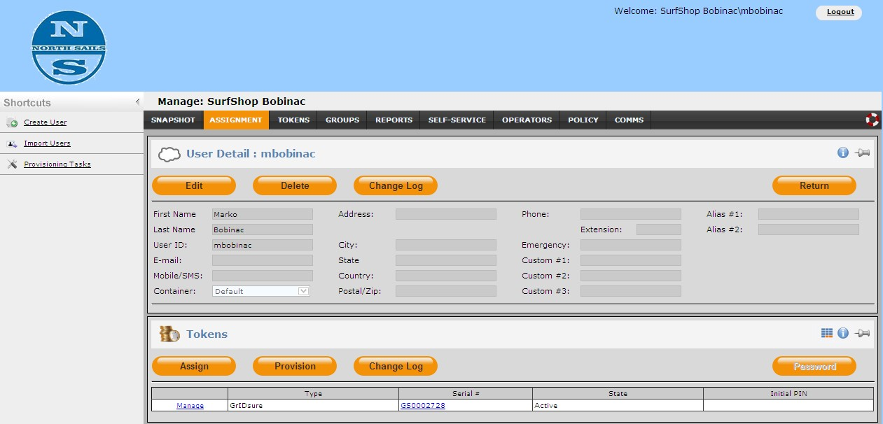

Step 2: Create URL for generating GrIDsure image.
Go to Self-service and uncheck Set customization Inherit.
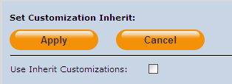
Go to Self-service Policy and copy Self-service Unique URL:
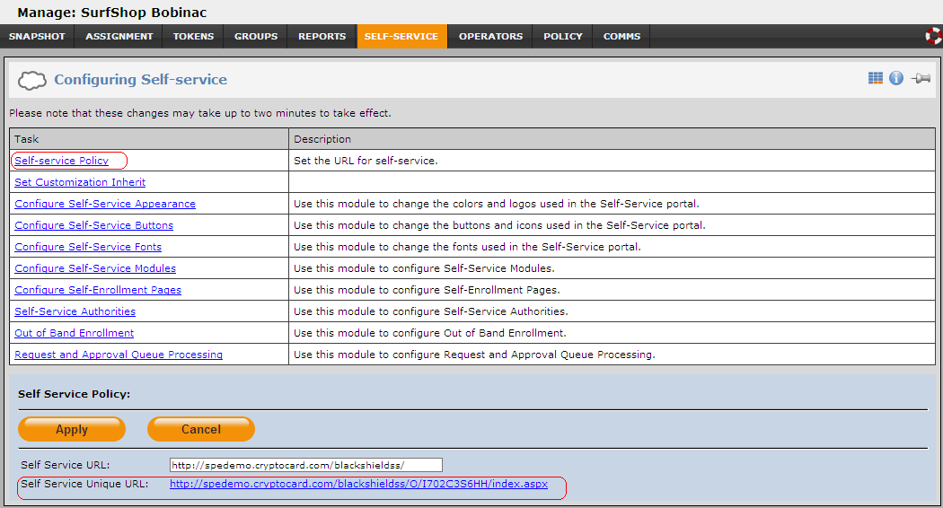
Remember the part before /index.aspx you will need to write it to PHP settings file! In case above it is http://spedemo.cryptocard.com/blackshieldss/O/I702C3S6HH
Comment: GrIDsure image URL is generated with that part+additional query data.
http://spedemo.cryptocard.com/blackshieldss/O/I702C3S6HH/SignIn.aspx?getChallengeImage=true&userName=mbobinac
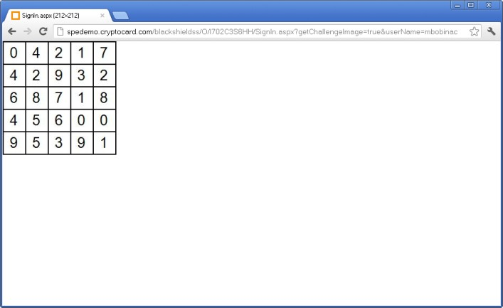

Step 3: Add your PHP server as the Authentication Node (setup under Comms tab)
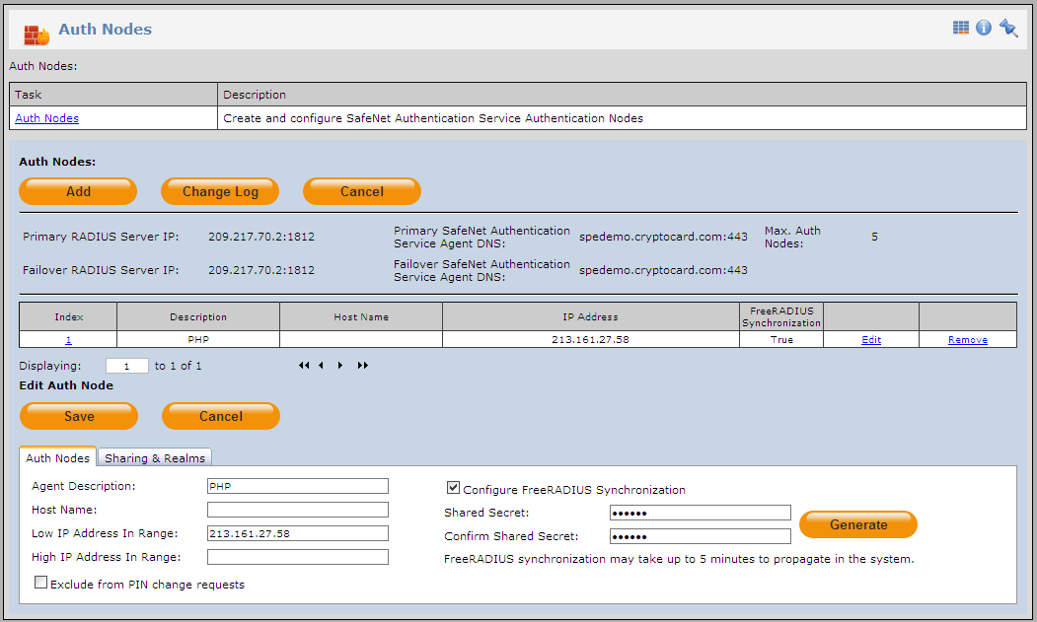

Part II – PHP Files

Step 1: Copy all sample files to a virtual directory on your server.
Files include sample class – you can create your own – PHP has native RADIUS support.

Step 2: Change data in inc/radius.data.php to match your registered Node in SAS.
$SAS_IP='209.217.70.2';
$SAS_Port='1812';
$SAS_Secret='secret';
$SAS_GridImageUrl='http://spedemo.cryptocard.com/blackshieldss/O/I702C3S6HH';

Part III – Demo

Step 1: Open demo page
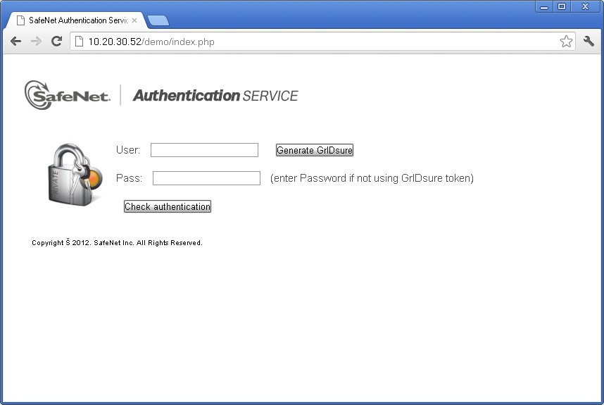

Step 2: If user has enrolled a GrIDsure token, enter Username into User field and press
GenerateGrIDsure button.
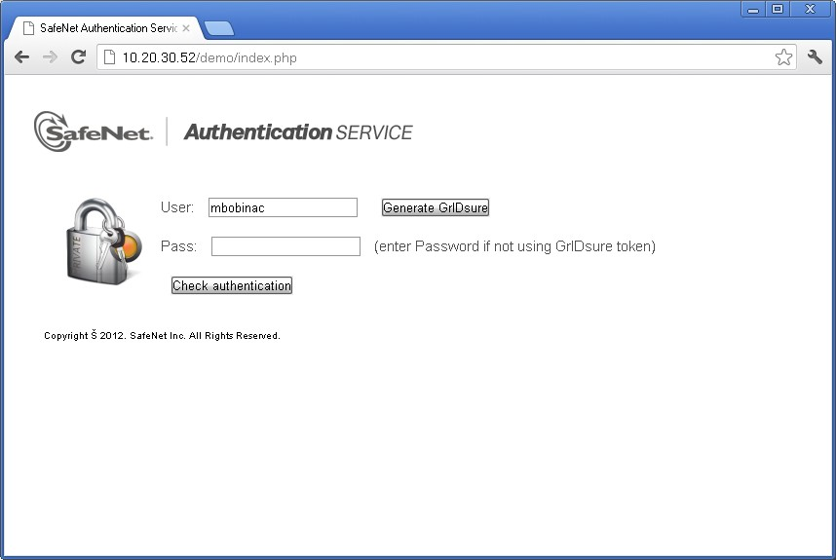

Step 3: GrIDsure is generated
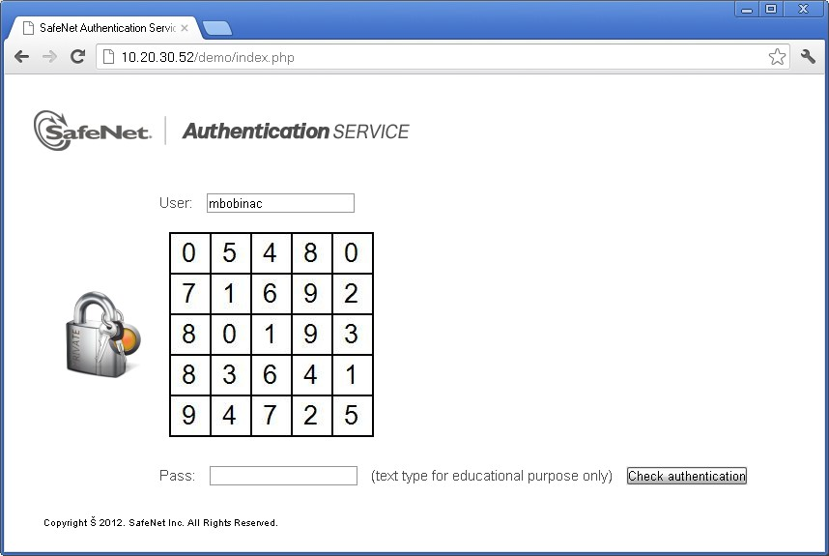
Also – GrIDsure image will not change until you successfully logon with your username.

Step 4: Enter your OTP and press Check authentication button. In case of authentication Success you will get:
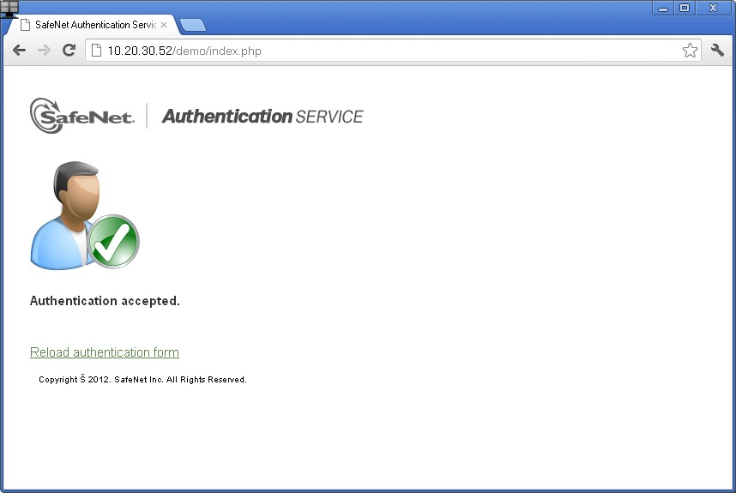
and in case of wrong OTP:
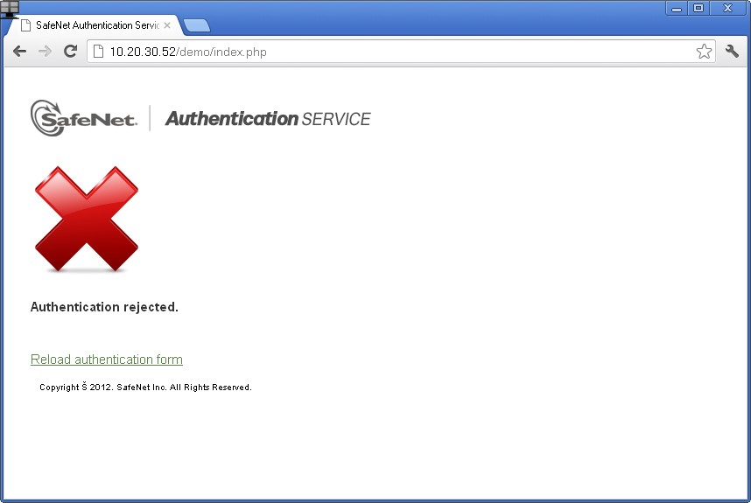

Part IV – Source code
Radius class: I used Radius class created by “SysCo systemes de communication sa” GNU licence. It is just a wrapper for PHP native support. You can create your own.
Radius Data: I created INC file with this settings
<?php
$SAS_IP='209.217.70.2';
$SAS_Port='1812';
$SAS_Secret='secret';
$SAS_Debug=False;
$SAS_GridImageUrl='http://spedemo.cryptocard.com/blackshieldss/O/I702C3S6HH';
?>
Radius calls:
$radius = new Radius($SAS_IP,$SAS_Secret);
if ($radius->AccessRequest($_POST['user'], $_POST['pass'])){
echo “Authentication accepted.”;
} else
echo "Authentication rejected.”;
}
Store user credentials on successful logon: It is up to you, use Session or any method you prefer.

